

Name: Abdulrahman Alawadhi
PRN: 25070122008
Branch: CSE
Subject: Programming with Java

ASSIGNMENT No.: 5
TITLE: :Develop a Java application demonstrating the use of ArrayList, Vector, and StringBuffer for dynamic data storage, management, and string manipulation.

Problem Statement:

Develop a Java application demonstrating the use of ArrayList, Vector, and StringBuffer for dynamic data storage, management, and string manipulation.

Learning Objectives:

To implement dynamic data storage and string manipulation using ArrayList, Vector, and StringBuffer.

Theory:

ArrayList and Vector are dynamic array implementations provided by the Java Collections
Framework. ArrayList offers faster performance in single-threaded applications, whereas Vector provides synchronized operations for thread safety. StringBuffer is a mutable sequence of characters that allows efficient string modification without creating new objects. These classes are commonly used in applications requiring dynamic memory allocation and efficient string processing.

Outcomes:
ArrayList, Vector, and StringBuffer enable efficient dynamic data storage and string manipulation, allowing flexible addition, removal, and management of data without fixed size constraints.

public class JAVA_EXP_5 {
public static void main(String[] args) {

ArrayList<String> arrayList = new ArrayList<>(); arrayList.add("Apple");
arrayList.add("Banana"); System.out.println("ArrayList: " + arrayList);

Vector<String> vector = new Vector<>(); vector.add("Car");
vector.add("Bike"); System.out.println("Vector: " + vector);

StringBuffer sb = new StringBuffer(); sb.append("Hello");
sb.append(" World");
sb.insert(5, ","); System.out.println("StringBuffer: " + sb);
}

}

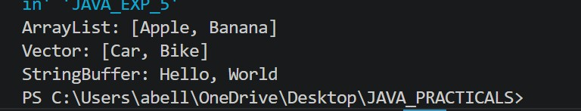

Conclusion:

This assignment demonstrates the effective use of ArrayList, Vector, and StringBuffer for dynamic data storage and string manipulation in Java. ArrayList provides fast, resizable storage for single-threaded applications, while Vector offers synchronized, thread-safe operations. StringBuffer enables efficient, mutable string handling without creating multiple objects.

Exercise:

- Create a To-Do List application using ArrayList to store tasks and StringBuffer to display tasks.
import java.util.ArrayList; public class JAVA_EXP_5{
ArrayList<String> tasks = new ArrayList<>();

void addTask(String task){ tasks.add(task);
}

void removeTask(String task){ tasks.remove(task);

}

void displayTasks(){
StringBuffer sb = new StringBuffer(); sb.append("To-Do List: \n");
for (int i = 0; i < tasks.size(); i++){ sb.append((i+1) + ". " + tasks.get(i) + "\n");
}
System.out.println(sb);
}

public static void main(String[] args) { JAVA_EXP_5 list = new JAVA_EXP_5();

list.addTask("Buy groceries");
list.addTask("play football");

list.addTask("Complete assignments"); list.addTask("Read a book");
list.displayTasks(); list.removeTask("play football");
System.out.println("After removing a task: ");
list.displayTasks();

}
}

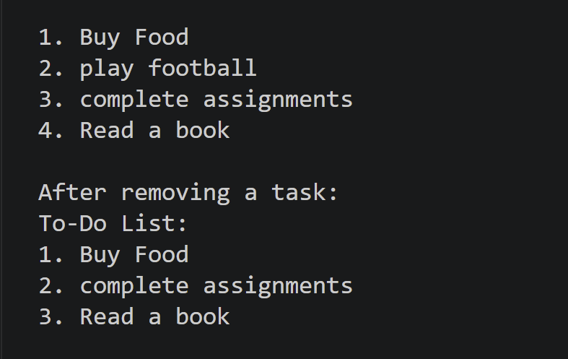

- Create a Student Course Registration System using ArrayList to store the list of courses registered by a student and StringBuffer to generate and display the registered course list. The application should allow users to add, remove, and view registered courses.

import java.util.ArrayList; public class JAVA_EXP_5{
ArrayList<String> courses = new ArrayList<>();
;

void addCourse(String course) { courses.add(course);
}

void removeCourse(String course) { courses.remove(course);
}

void viewCourses() {
StringBuffer sb = new StringBuffer(); sb.append("Registered Courses:\n");
for (int i = 0; i < courses.size(); i++) { sb.append((i + 1) + ". " + courses.get(i) + "\n");
}
System.out.println(sb);
}

public static void main(String[] args) { JAVA_EXP_5 reg = new JAVA_EXP_5();

reg.addCourse("Java Programming");
reg.addCourse("Database Management"); reg.addCourse("Computer Networks");
reg.viewCourses(); reg.removeCourse("Computer Networks");
System.out.println("After removing a course:");
reg.viewCourses();
}
}
